2-2 Milestone One: Code Review Transcript
CS 499: Computer Science Capstone
Taylor Doyka
03/11/2026
Satish Penmatsa

Hello Everyone! Today I am presenting my enhancement plan for the CS 360 Final Project, which focuses on Mobile Architecture and Programming.
The original artifact is an Android-based Inventory Management Application. It’s core purpose is to help users track items in a warehouse or small business setting. In its current state, the app allows users to view a list of items, add new entries to a local database, and perform basic deletions.
CATEGORY ONE: SOFTWARE ENGINEERING AND DESIGN
I am presenting my Category One artifact for my Computer Science Capstone: a professional-grade refactoring of the Inventory Management App originally developed in CS 360, Mobile Architecture and Programming.
In its original form, this Android application was a functional prototype designed to help small businesses track stock levels. It allowed users to register, log in, and perform basic CRUD operations; Create, Read, Update, and Delete; on an inventory database. It also featured an SMS alert system for low-stock notifications. While the app 'worked' from a user perspective, a deep dive into the source code revealed significant architectural and security technical debt. My goal for this capstone was to transform this 'student project' into an enterprise-ready mobile solution by focusing on Software Design and Engineering principles.
To begin my enhancement, I performed a comprehensive code review based on industry-standard criteria. The original CS 360 code followed a 'God Object' pattern, where the Activities; the screens the user sees were responsible for everything. They handled UI rendering, database queries, and business logic simultaneously. This tight coupling made the code nearly impossible to unit test and very difficult to maintain.
Efficiency was another major concern. The original app executed database queries directly on the Main Thread. In a real-world scenario with thousands of inventory items, this would cause the UI to freeze or 'jank,' leading to poor user experience. Furthermore, the security posture was weak. User sessions were stored in plaintext, and the raw SQLite queries were vulnerable to SQL injections if not handled carefully. Finally, the lack of structured error handling meant that if a database write failed, the app would either crashes or leave the user in an uncertain state without feedback.
My primary enhancement focused on a total structural overhaul using the MVVM (Model-View-ViewModel) design pattern. By introducing a ViewModel layer, I decoupled the UI from the data. The Activity now only 'observes' data changes, while the ViewModel handles the logic. This supports Course Outcome 2, as I am designing and evaluating a computing solution that is modular and scalable.
I also migrated the data layer from raw SQLite to the Room Persistence Library. Room provides an abstraction layer that allows for compile-time checks of SQL queries, preventing runtime crashes. To solve the threading issues, I implemented Kotlin Coroutines. This ensures that every database transaction, whether adding a new pallet of goods or updating a price happens on a background thread. This keeps the UI responsive and fluid, demonstrating a professional level of software engineering efficiency.
Security was the next pillar of my enhancement. To protect user data, I implemented EncryptedSharedPreferences. This ensures that even if a device is compromised, the user's login tokens and preferences are AES-256 encrypted at the system level. I also added strict input validation patterns (Regex) across all entry fields to ensure data integrity and prevent malicious injections.
Furthermore, I moved the app toward a 'Defensive Programming' model. I replaced silent failures with a robust error-handling framework. Now, if the database is full or a network call fails, the app catches the exception and provides the user with a 'Snackbar' notification. This change aligns with Course Outcome 4, demonstrating professional and ethical practices by prioritizing data security and reliable user experience.
Throughout this process, I have demonstrated several key industry skills: Advanced Android development, asynchronous programming with Coroutines, and architectural design.
This project supports all five course outcomes. By refactoring the code into a readable, standardized format, I support Outcome 1 (Collaborative Environments). Through the MVVM transition, I met Outcome 2 (Design and Evaluate Solutions). I addressed Outcome 3 (Communication) by providing clear technical documentation and Javadoc commenting. My security hardening satisfies Outcome 4 (Professional/Ethical Practices). Finally, the entire process of taking a functional app and making it 'better'; rather than just 'done'; embodies Outcome 5, the mindset of continuous professional improvement.
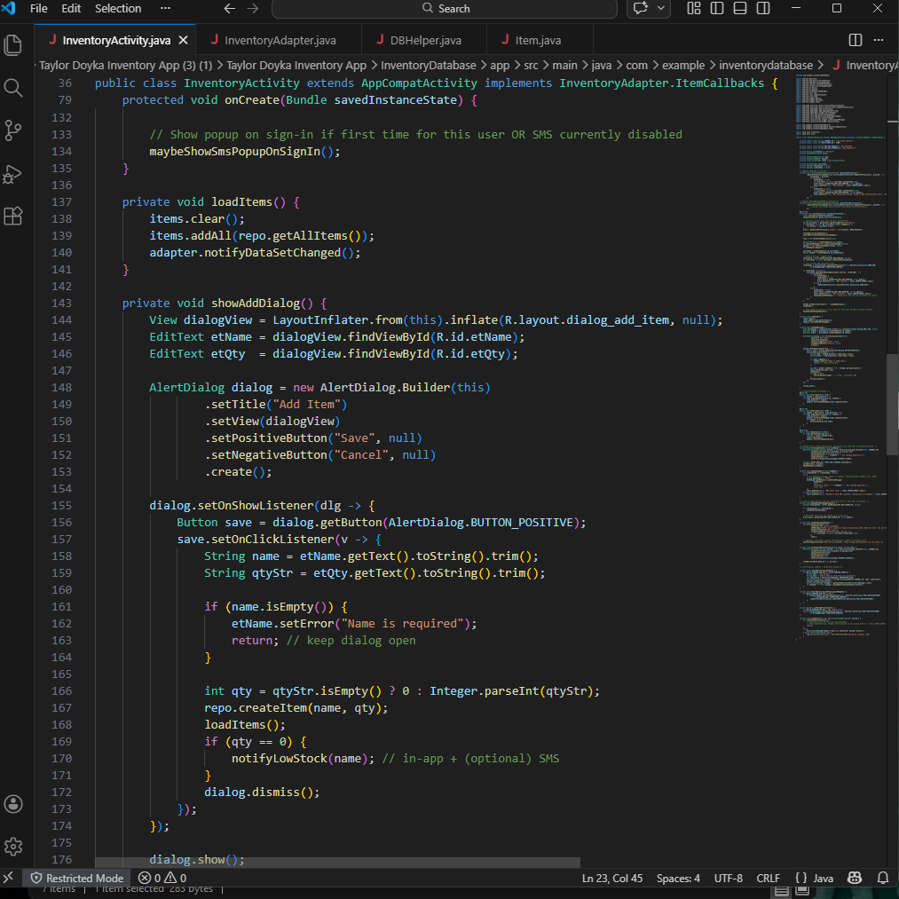

CATEGORY TWO: ALGORITHMS AND DATA STRUCTURES
In its current form, the application serves as a standard mobile tool for tracking warehouse stock. Its primary functionality revolves around basic CRUD operations; Create, Read, Update, and Delete. A user can input an item name, a description, and a numerical quantity. This data is then sent to a local SQLite database and pulled back to the UI, usually displayed in a standard vertical list.
The current code relies heavily on the Android framework's default behavior. For example, when a user searches for an item, the app iterates through a simple ArrayList of objects until it finds a match. While this works for a small inventory of ten or twenty items, it represents the "baseline" of mobile development. It is functional, but it lacks the sophistication needed to handle scaling, high-speed data retrieval, or complex relationships between data points. My goal for this milestone was to look "under the hood" and turn this basic storage tool into an efficient data management system.
During my code review, I evaluated the artifact against several key criteria: efficiency, security, and error handling. I found several critical weaknesses that hinder the app’s professional viability. First, the search and sort logic is inefficient. Currently, the app uses linear search meaning if the inventory grows to thousands of items, the search time increases linearly, leading to noticeable UI lag. Furthermore, there is a total lack of input validation. If a user enters a negative number or a string where an integer is expected, the app either crashes or saves corrupted data to the database, which is a major flaw in data integrity.
From a security and structural standpoint, the existing code uses raw SQL queries that are not fully parameterized, leaving a small but real opening for SQL injection. Additionally, all database operations are currently running on the main UI thread. This is a "code smell" in Android development because it risks "Application Not Responding" (ANR) errors. The lack of proper commenting and documentation also makes the code difficult for a secondary developer to maintain. These findings highlight that while the app "works," it is not yet "engineered" for performance or reliability.
To address these findings, I am implementing a series of algorithmic and structural enhancements. First, I am moving away from simple list iterations and implementing a Binary Search Algorithm for item lookups. To support this, I will introduce a QuickSort or MergeSort algorithm to keep the inventory sorted by ID or name automatically. I am also implementing a HashMap as an in-memory cache to allow for near-instant retrieval of frequently accessed items.
Beyond pure algorithms, I am upgrading the data structures used for input validation. I will implement a "Validator" class that uses regular expressions to scrub user input before it ever reaches the database. To solve the threading issue, I will utilize Asynchronous Tasks or Executors to ensure that data-heavy operations happen in the background. This ensures the UI remains butter-smooth. Finally, I will refactor the SQLite code to use parameterized queries and a more modular "Data Access Object" (DAO) pattern, which separates the database logic from the UI logic, making the code much cleaner and easier to test.
These enhancements allow me to demonstrate several high-level technical skills. By implementing custom sorting and searching, I am showing a deep understanding of computational complexity and the ability to choose the right tool for a specific data problem. My work on input validation and background threading demonstrates a commitment to defensive programming and software quality assurance. These are not just "features"; they are the pillars of professional-grade software engineering.
This project directly supports several of our course outcomes. Most notably, it aligns with Outcome 4, which focuses on designing and evaluating computing solutions that solve specific problems; in this case, the problem of data scale and speed. It also addresses Outcome 5 by requiring me to communicate these technical findings and strategies to a professional audience. By the end of this enhancement, the Inventory App will move from a simple classroom exercise to a robust, efficient, and secure application ready for real-world data management.
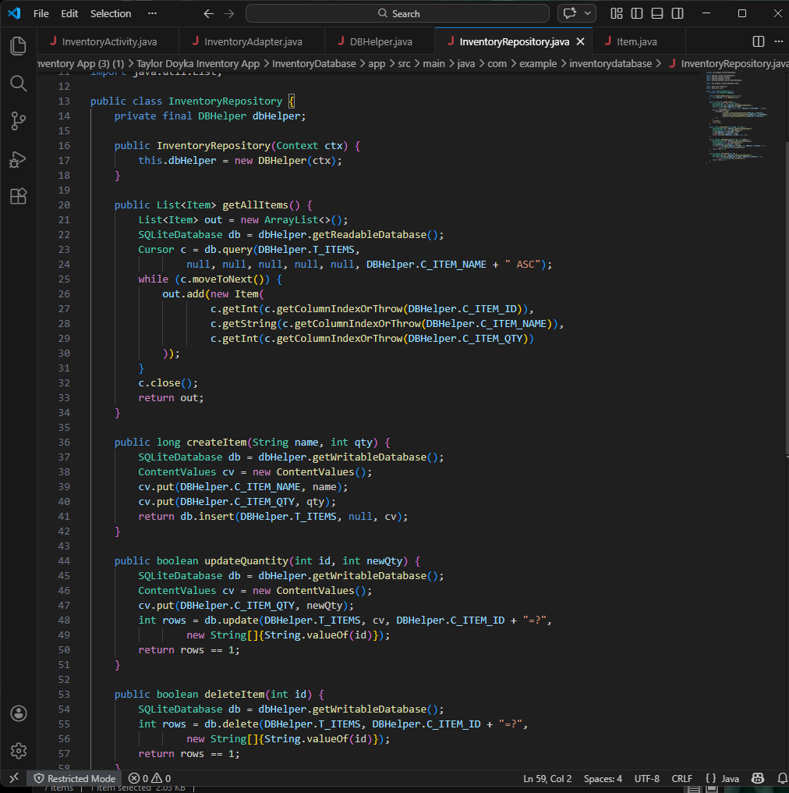
CATEGORY THREE: DATABASES
The original artifact for this project is an Android-based Inventory Management application designed to help users track stock levels in real-time. In its current state, the app provides basic CRUD (Create, Read, Update, and Delete) functionality through a local SQLite database. Users can log in to a private dashboard, add new items with specific quantities, view a scrollable list of their current inventory, and update or remove items as stock fluctuates. A core feature of the existing code is a "low-water mark" trigger; the app monitors quantity levels and is programmed to send an SMS notification to the user whenever an item's count drops below a predefined threshold. This ensures that the database doesn't just store data but actively informs the user's business decisions.
Upon conducting a critical code review using industry-standard criteria, several significant weaknesses were identified in the database layer. First, from a security standpoint, the original code lacks data encryption; user credentials and inventory details are stored in plain text, making the app vulnerable if the device's storage is compromised. Furthermore, the code lacks robust error handling. Database transactions are performed without sufficient try-catch blocks, meaning a simple null pointer or a full disk could cause the entire application to crash. From an efficient perspective, the original architecture performs database queries directly on the Main (UI) Thread. This is a poor practice in mobile development that leads to "jank" or UI freezing, especially as the database grows. Finally, the logic is tightly coupled; the Activity classes are doing too much "heavy lifting" by managing both the user interface and raw SQL queries, making the code difficult to maintain or scale.
To address these findings, the enhancement plan targets four specific areas: structure, security, efficiency, and functionality. I plan to refactor the database architecture by moving away from raw SQLite helpers and implementing the Room Persistence Library. This will provide a more abstract-heavy, compile-time checked approach to data management. Security will be bolstered by implementing parameterized queries to prevent SQL injection and adding a hashing layer for user passwords. To improve efficiency, I will move all database interactions to background threads using Asynchronous Tasks or Coroutines, ensuring the UI remains responsive. Functionally, I will also implement data validation at the database entry point to ensure that negative stock levels or empty item names cannot be committed to the record.
These enhancements are designed to demonstrate a high level of technical proficiency in mobile architecture and secure data management. By completing this work, I will demonstrate the ability to refactor legacy code into a modern, Repository-pattern based system. This project specifically supports three major course outcomes: Outcome 2, by designing and evaluating a computing solution that meets specific requirements; Outcome 4, by demonstrating professional communication through detailed technical documentation of these changes; and Outcome 5, by implementing security-first mindsets to protect user data. Ultimately, this transition from a functional prototype to a secure, efficient, and well-structured application proves my readiness to handle professional-grade software development challenges.
